**Ironworks Battery SMBus Reader**

**Design by Anthony KN6ZZY**

**Original Idea and Code by Paul W9PEM**

*This board is designed to fit on Ironworks LiFePO4 batteries. It may function on other batteries that use the SMBus protocol, but I cannot guarantee that the wiring will match. This design is not a battery protection circuit, just a convenient display of the battery’s own data.*

**Assembly:**

1. Ensure that all components in package are present, and that no pins or sockets were bent in transit (LCD and regulator have pins on underside).

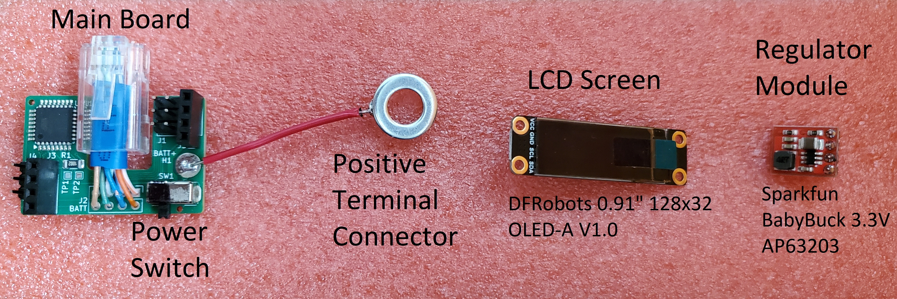

1. Insert **Main Board** plug into battery’s SMBus port. Board should fit smoothly and snugly into place with a *click* when secure. This may require bending the positive terminal’s wire upwards out of the way.

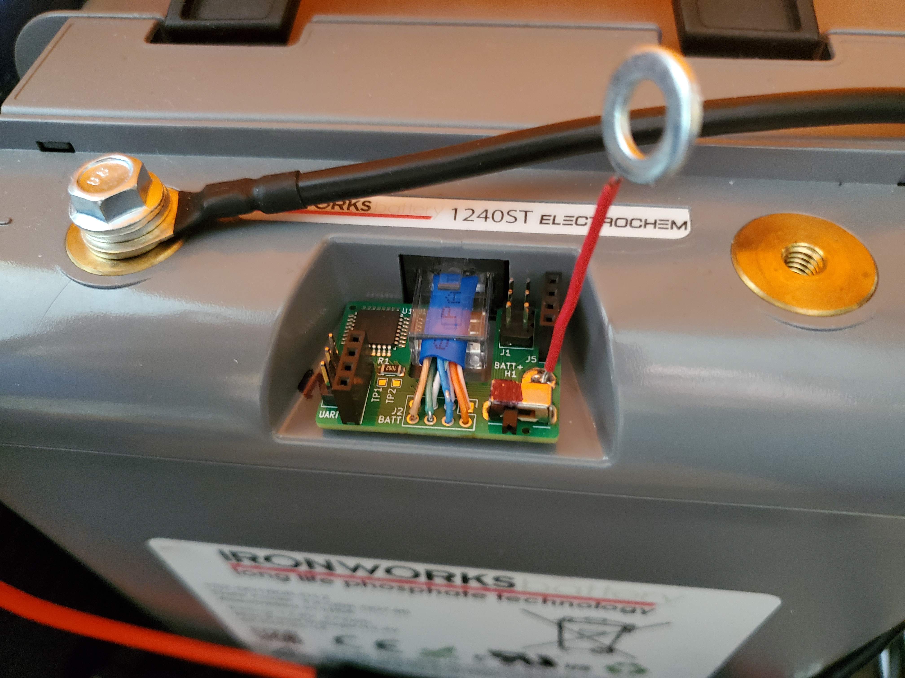

1. Ensure that the power switch on the board is set to the **OFF** position (**Black / Left** in these images) and bend the **Positive Terminal Connector** into place.

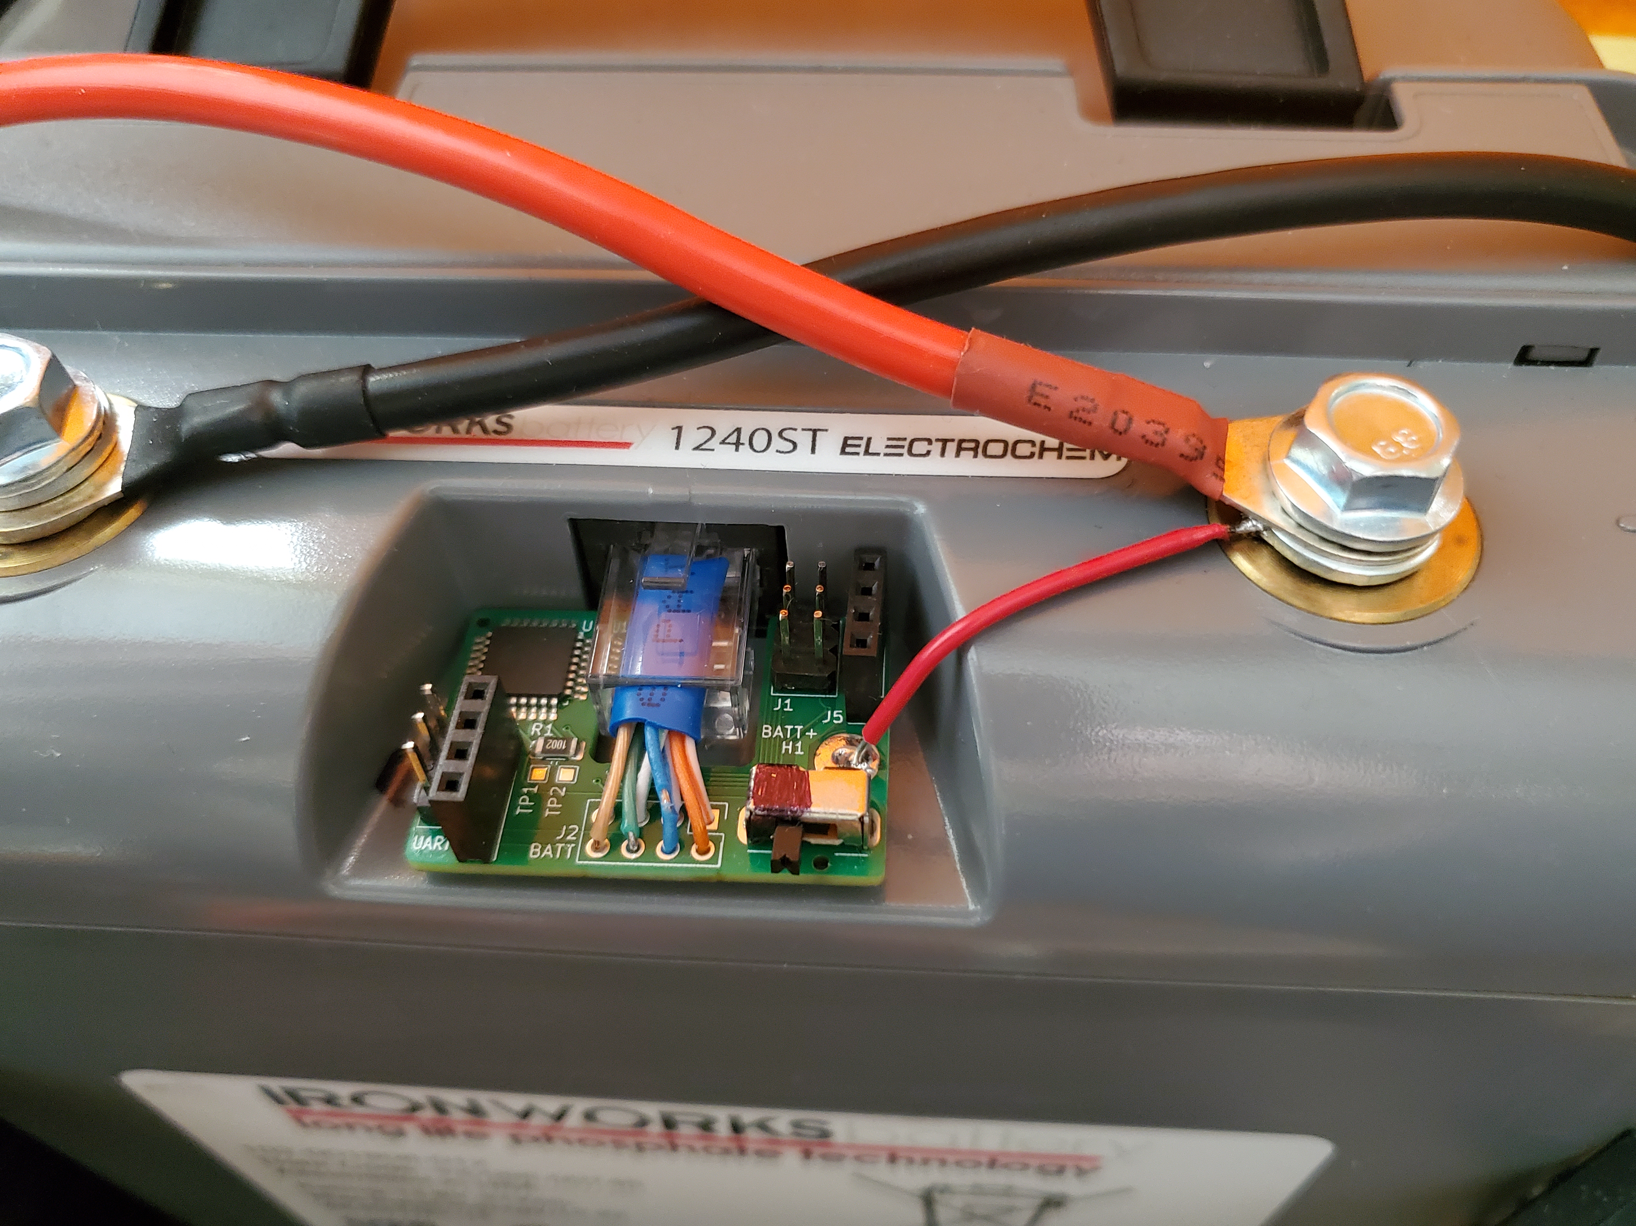

1. Insert the **Regulator Module** into the upper-right socket on the Main Board, then insert the **LCD Screen** into the lower-left socket.

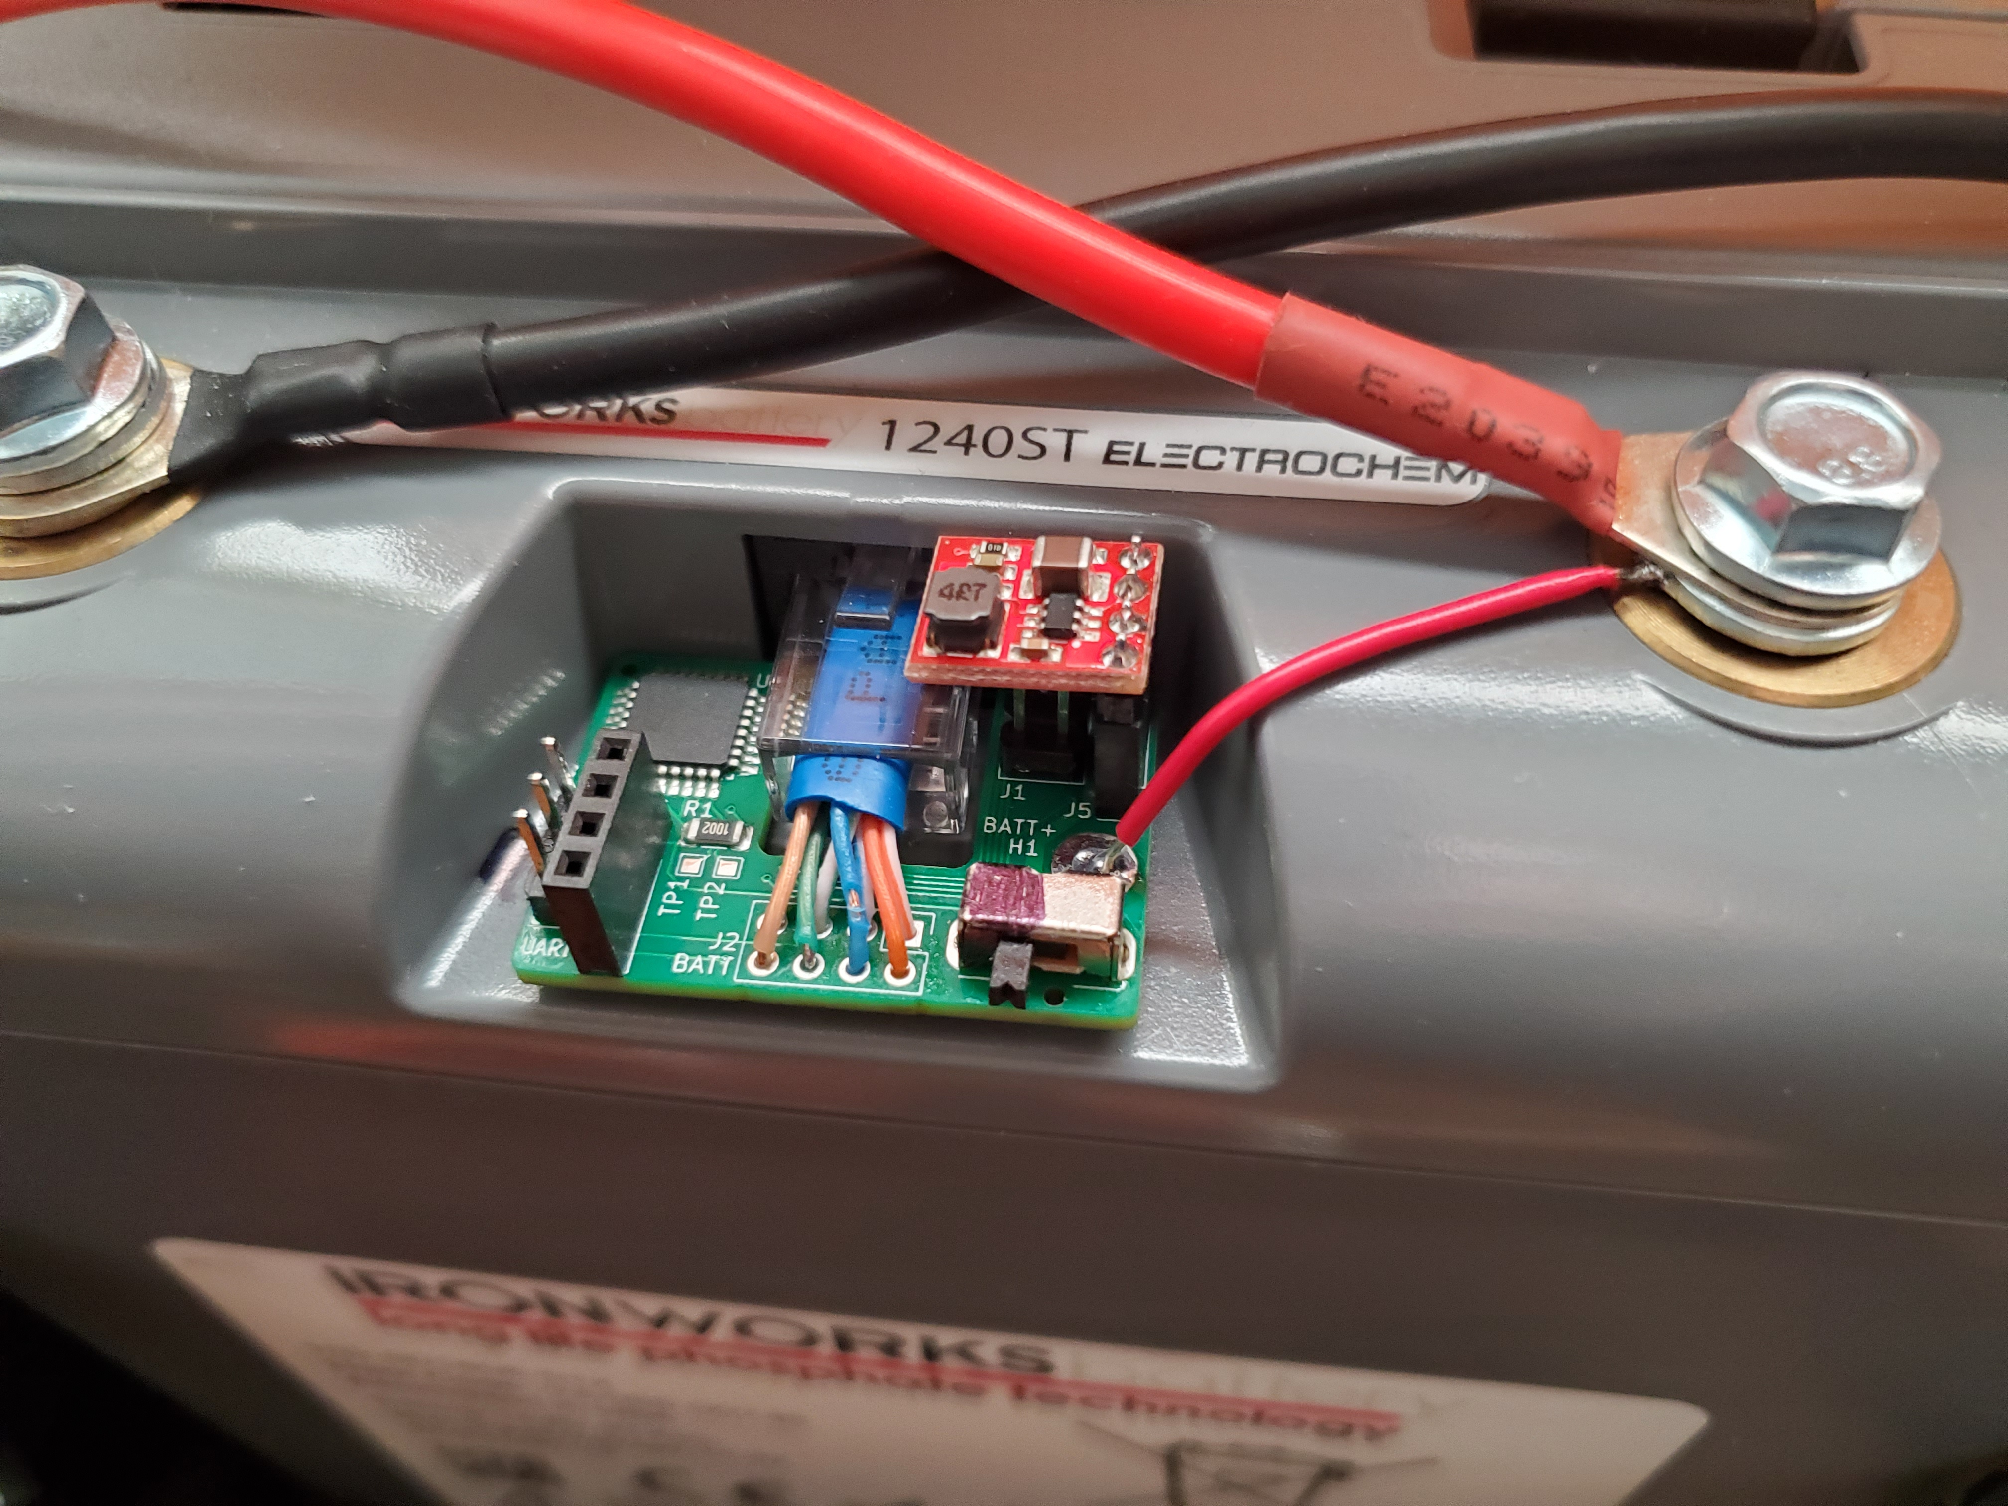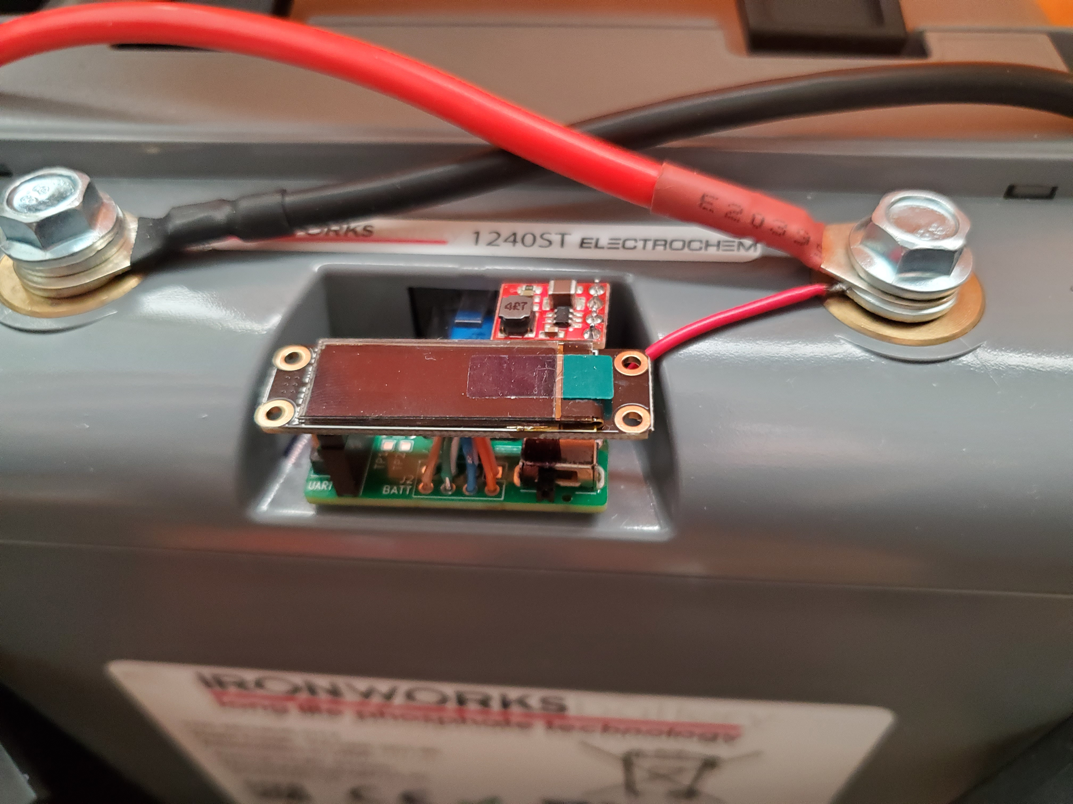

1. You may now switch **ON** the board (SILVER / right) and ensure it functions: It should show “KN6ZZY W9PEM” briefly, then alternate between **Voltage / Current** and **Capacity** displays. Note that the Current may say “disconnected” if the battery is not under load.

If the board remains on the boot screen, or displays a 🔋**?** symbol, it may not be connected to the battery properly. Turn the board off, remove the LCD and regulator, and ensure that the RJ-45 plug is properly seated.

Full BMS data is written out through the “UART” header on the left side if you want it. The pin ordering from top to bottom is: **GND, TX, RX**.